**ORM Web Services**

**Final Project: Article Management**

**Group: 3**

Member of Group 3: **NANH Bunsin**, **Ngorn Lyhour** & **CHHAY Laing**

**Note:** all ER Diagram files we already store them into git repo into folder public like ER Diagram and docs. And API documentation please check my README.md.

System Prerequisites

Programming languages

* Backend
  + NodeJS, Prisma, Postgres,
* Frontend
  + ReactJS, HTML, CSS, Bootstrap

Content

* Responsible By NANH Bunsin
  + Integrate with Prisam, Postgres
  + Design frontend
  + CRUD Users (Backend & Frontend)
  + Login, Register, Logout
* Responsible By Ngorn Lyhour
  + CRUD Articles (Backend & Frontend)
  + Design Project Documentation
* Responsible By CHHAY Laing and some assist from Lyhor
  + Design slide
  + Project report

Tables diagram:

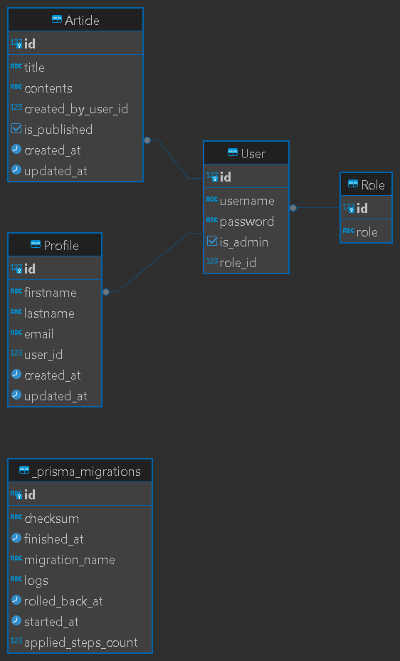

Note: all project ideas we are collaboration together and presentation slide as well.